**Justice Party of Pennsylvania**

**Financial Report for May 2013**

**Prepared By:**   
Aaron Morris  
Treasurer

June 6, 2013

**Summary- May 2013**

**Balances**

|  |  |  |
| --- | --- | --- |
| **Account** | **Beginning Balance (on May 1)** | **Ending Balance (on May 31)** |
| Checking (Orrstown Bank) | $50.00 | $167.94 |
| PayPal | $19.12 | $0.00 |
| **Total** | **$69.12** | **$167.94** |

**Cash Flow**

|  |  |
| --- | --- |
| **Beginning Balance** (on May 1) | **$69.12** |
| Receipts |  |
| *Monetary (e.g. .cash, check, credit card)* | *$120.00* |
| *In-Kind* | *$10.70* |
| Total Receipts | $130.70 |
| Disbursements |  |
| *Operating Expenses* | *$11.88* |
| *Refunds* | *$20.00* |
| Total Expenses | $31.88 |
| **Net Change** | **$98.82** |
| **Ending Balance** (on May 31) | **$167.94** |

**Financial Analysis for May 2013**

**Income vs. Expenses by Category – May 2013**

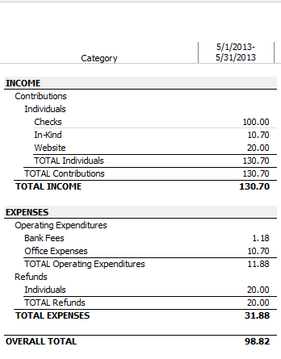  
  
***Note****: The $20 refund was made to Blyden Potts of Shippensburg, Pa for a contribution he made on 1/15/2013 which was not processed within 10 days as required by federal law (11 C.F.R. 103.3(a)).*

**Income vs. Expenses by Payee – May 2013**

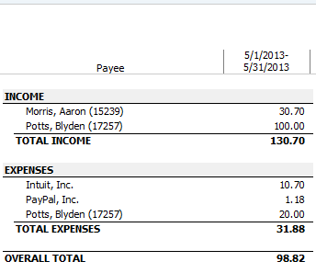

**Financial Analysis for Year-to-Date**

**Income vs. Expenses by Category – YTD (Quarterly)**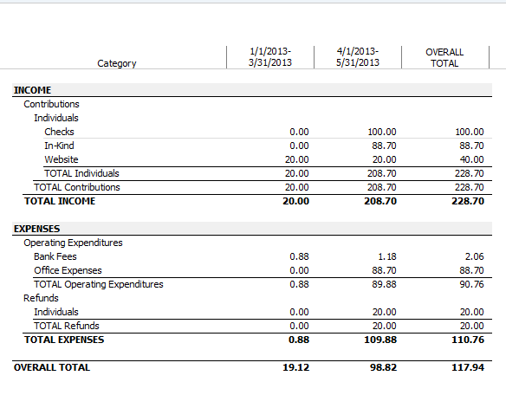

**Income vs. Expenses by Payee – YTD (Quarterly)** 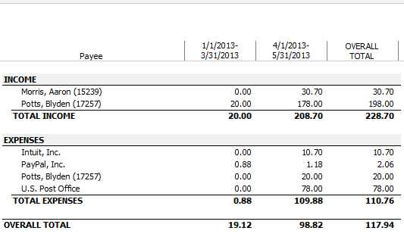

**Appendix A:   
Audit of Checking Account**